Adaptive Leadership Micro-refresher Module

1. Adaptive Leadership

1.1 Welcome - Adaptive Leadership Micro-module
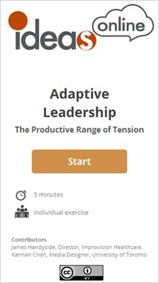

Note:
Concept testing for online.ideasontario.ca
Your action on this tool might be tracked by Google Analytics for research and development purposes.

Attribution (Slide Layer)
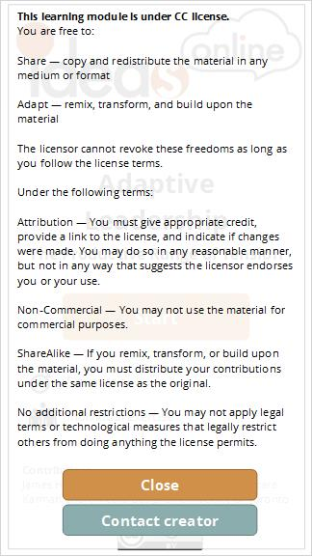

1.2 3-minutes exercise
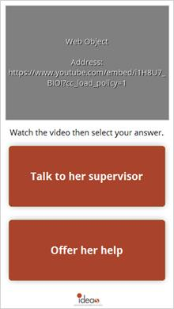
Notes:
You have just asked Chris for the third time to join the QI meeting to discuss the changes you are planning to test.
She again says there's too much on her plate right now. You really need her to get on board. You are not her peer or supervisor so you are at a loss on what to do.
Call her supervisor and convince her to influence Chris that this is important and she should come
Or ask Chris if there's anything you might do to clear the time.
What should you do?
Button: Talk to her supervisor
Button: Offer her help

1.3 How about that?
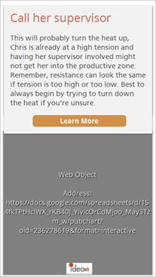
Notes:
Outcome: Call her supervisor
This will probably turn the heat up, Chris is already at a high tension and having her supervisor involved might not get her into the productive zone. Remember, resistance can look the same if tension is too high or too low. Best to always begin by trying to turn down the heat if you’re unsure.
Learn more at http://online.ideasontario.ca/topic/fundamentals-of-adaptive-change/
Outcome: Offer her help
If successful this could turn the heat down and you’ll probably know as soon as you ask. Always turn the heat down first.
Share it! https://twitter.com/ideasontario

2. How this works

2.1 Read me
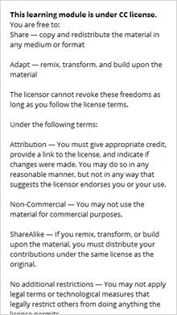

2.2 Setup
